Topic: Pharmaceutical Chemistry 2.
Lecture 3: Drugs affecting the adrenergic system.

Adrenergic drugs include adrenomimetics, adrenoblockers, sympatholytics.
Sympathetic postganglionic fibers are adrenergic: their ends secrete noradrenaline (norepinephrine) as a mediator (exciter transmitter). The synapses of the postganglionic fibers of the sympathetic nervous system are adrenergic. Schematic representation of the structure of the human autonomic nervous system and the organs innervated by it.
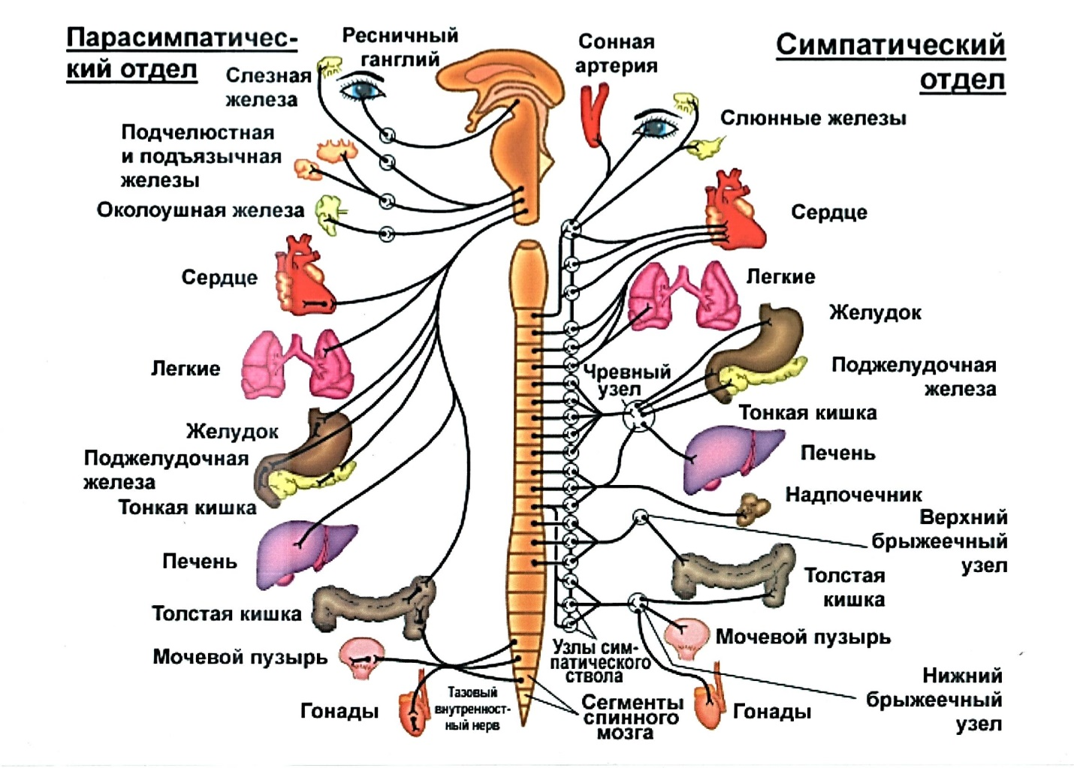
The influence of the sympathetic nervous system on the activity of various organs and systems:
Orqan | Seçimlər
Orqan | Seçimlər | parasimpatik innervasiya | simpatik innervasiya
Ürək | Ritm  (sancılar tezliyi) | Azaldılmış (bradikardiya) | Yüksəlmə (taxikardiya)
Ürək | Sancılar gücü | Azaldılmış (atriyal) | Qazanc  (atriyal)
Ürək | Keçiricilik | yavaşlama | Sürətlənmə
Gəmilər | Hamar əzələ tonu | Azalır | yüksəlir
CƏHƏNNƏM |  | eniş | Qaldırmaq
Bronxlar | Hamar əzələ tonu | yüksəlir | Azalır
Bronxlar | bronxial bezlərin sekresiyası | yüksəlir | Azalır
Mədə və bağırsaqlar | Peristaltika və hərəkətlilik | yüksəlir | Azalır
Mədə və bağırsaqlar | Sfinkter tonu | Azalır | yüksəlir
öd kisəsi, kanal | Hamar əzələ tonu | yüksəlir | Azalır
Sidik kisəsi | divar tonu | daralma | yüksəlir
Sidik kisəsi | Sfinkter tonu | Rahatlayır | Daralma
Göz | İrisin dairəvi əzələsinin tonusu | Artan (mioz) | Azalır (midriaz)
Göz | Göz içi təzyiqi (GİB) | Azalır | yüksəlir

In the 1940s, scientists who studied the reactions of various organs and tissues to the reception of adrenaline and its analogues discovered that there should be at least two types of receptors in the cell for these substances, one of which relaxes the smooth muscles of the blood. veins, and the other stimulates the heartbeat. These imaginary cellular structures Raymond Ahlquist tentatively called alpha and beta-adrenergic receptors. Robert Lefkowitz labeled the adrenaline molecule with radioactive iodine atoms and thereby "calculated" the adrenoceptor in various cell structures. Robert Lefkowitz and Brian Kobilka received the Nobel Prize in Chemistry in 2012 for the discovery of G-protein coupled receptors. "About half of all drugs act through G-protein-coupled receptors"
The neurotransmitter in the adrenergic synapse is norepinephrine.
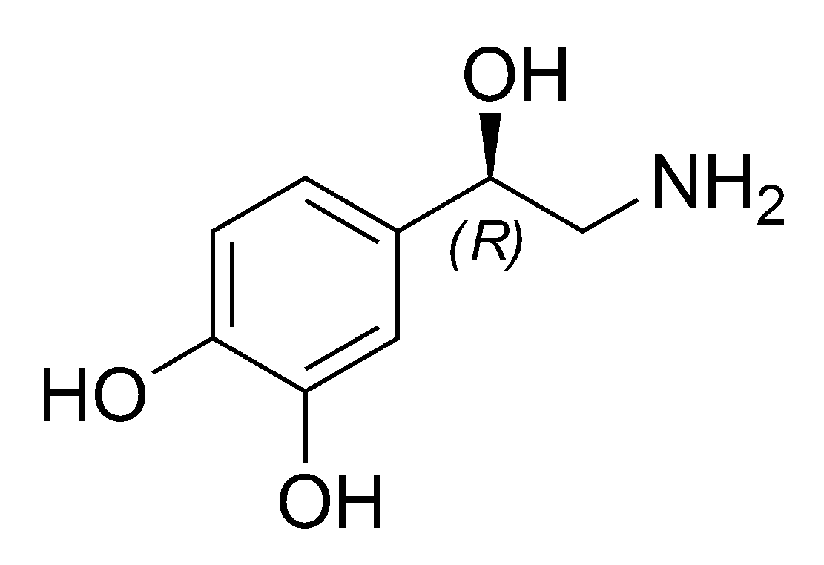
Norepinephrine is synthesized from the amino acid phenylalanine, phenylalanine is converted to tyrosine, DOPA is formed, and dopamine is formed from it. Inside the vesicles, dopamine is converted to norepinephrine.
Biosynthesis of neurotransmitters of the sympathetic-adrenal system:
Norepinephrine stimulates adrenoreceptors.
Norepinephrine acts for a short time - most of it (about 80%) is taken up by nerve endings. In the cytoplasm, part of norepinephrine is exposed to monoamine oxidase (MAO), but more norepinephrine is taken up by vesicles.
Norepinephrine is metabolized by the cytoplasmic enzyme catechol-o-methyltransferase (COMT). Norepinephrine O-methylation occurs under the influence of COMT.
The presence of two types of alpha-adrenergic receptors and three types of beta-adrenergic receptors, designated as α1-AR, α2-AR, β1-ΑΡ, β2-ΑΡ and β3-ΑΡ, have been identified.

Adrenoreceptors
α1 | α2 | β1 | β2 | β3
radial muscle of the eye; vessels of smooth muscles of organs, skin, kidneys, veins; arterioles; liver; myometrium | CNS; peripheral veins; platelets | Heart; ciliary body of eyes; kidneys; platelets | smooth muscles of the bronchi; myometrium, coronary vessels, skeletal muscles; bronchi; liver | fat cells

β1-AR is located in the heart muscle, when they are excited, heart contractions increase and become more frequent. Facilitates the conduction of impulses from the atria to the ventricles, increases the automaticity of the heart. β1-ΑΡ is also located in the juxtaglomerular apparatus of the kidneys, where it participates in the regulation of blood circulation and urine output in the kidneys, affects the general hemodynamics and water-salt exchange in the body. The juxtaglomerular (JGA) or periglomerular apparatus of the kidneys is a collection of cells that synthesize repin and other biologically active substances. Renin catalyzes the production of angiotensins in the body, aldosterone in the adrenal glands, and antidiuretic hormone in the hypothalamus.
Blood vessels, bronchi, uterus contain β2-ΑΡ, when they are excited, relaxation of bronchial muscles and uterus occurs.
β3-ΑΡ of adipose tissue stimulates fat breakdown (lipolysis), energy release, and heat production.
Subtypes of adrenoreceptors and the effects produced by their stimulation.
α1
 Vascular smooth muscle contraction (vasoconstriction)
 Constriction of the radial muscle of the iris (dilation of the pupils)
α2(extrasynaptic)
 Vascular smooth muscle contraction (vasoconstriction)
α2 (presynaptic)
 Decreased release of noradrenaline by the ends of adrenergic fibers
β1
 Increase:
 heart rate power
 heart palpitations
 atrioventricular conduction
 Renin secretion by the juxtaglomerular cells of the kidneys
β2 (extrasynaptic)
 Relaxation of smooth muscles of blood vessels, bronchi, uterus:
 dilation of blood vessels
 bronchial dilatation
 reduction of myometrium tone and contractile activity
 Activation of glycogenolysis in the liver
Agents affecting adrenergic synapses are divided into:
LP, excitatory adrenergic synapses;
Substances that directly stimulate adrenergic synapses - adrenomimetics (AM) and substances that enhance the release of a mediator - sympathomimetics.
LP blocks adrenergic synapses.
Substances that inhibit adrenergic transmission of awakening - adrenoblockers (AB). Agents that reduce mediator release or degradation are sympatholytics.

There are α1-agonists (α1-AM), α2-agonists (α2-AM), β-agonists (β-ΑM), β1-agonists (β1-ΑM), β2-agonists (β2-ΑM). αβ-adrenergic agonists (αβ-ΑΜ) stimulate both alpha and beta adrenergic receptors.
Stereoselectivity of enantiomers with respect to receptors.
Classification of adrenomimetics.
1. Adrenomimetics of direct effect:
α,β - adrenomimetics:
• epinephrine hydrochloride;
• norepinephrine hydrotartrate.
α - adrenomimetics:
• mesatone;
• Naftizine;
• Galazolin.
β1β2 - adrenomimetics:
• isadrin.
β2 - adrenomimetics (selective drugs):
• salbutamol;
• fenoterol;
• terbutaline.
2. Indirectly acting adrenomimetics (sympathomimetics):
ephedrine hydrochloride.
Classification of adrenoblockers.
α1α2-blockers:
• pyroxane;
• trophofen;
• phentolamine hydrochloride.
α1-blockers:
• prazosin.
β1β2 - blockers:
• anaprilin;
• oxprenolol.
β1 - blockers (cardioselective):
• metaprolol;
• talinolol;
• atenolol.
Sympatholytics:
• octadine;
• reserpine.
Interest in different receptors:
a- Difference in chemical structure as a natural consequence
b- Various physical and chemical properties
* The difference of alkyl groups is related to the basicity "N".
Conformational properties of catecholamines.
The 1N NMR spectral spectrum is illuminated by quantum mechanical calculations:
CC gives side-chain rotamers:

Decongestant bronchodilators

Molecular property responsible for the adrenergic effect: The main requirement is the presence of the phenethylamine skeleton, and the effect is independent of the enantiomeric configuration.

Physiological condition Presence of 2-phenylethylammonium

It is effective against the α1 receptor
It is effective against β2 receptor
Structure-activity relationship

Changes in the alkylation of the "N" group lead to differences in the activity of beta receptors.
Phenyl ring
-m,p-diphenolic = increases affinity to sympathetic receptors.
monophenol = has peripheral local effects.
When the phenolic group is in the "o" position, the sympathomimetic effect is significantly reduced.
*Methylation of the phenol group (methoxamine) reduces some sympathomimetic effects.
*-NH2 methylation: the transition from primary to secondary amine is not much different if the rest of the structure is the same (epinephrine, norepinephrine).
*When replacing lowercase "C" with "N":
For example, in isoprenaline = hypertonic effect disappears, bronchodilator effect appears.

Biotransformation:
All three natural catecholamines—norepinephrine, epinephrine, and dopamine—act as neurotransmitters in the central nervous system. The main metabolic transformations of catecholamines include O-methylation at the metahydroxyl group and oxidative deamination. The O-methylation process is catalyzed by the enzyme catechol-O-methyltransferase (COMT), and oxidative deamination is facilitated by monoamine oxidase (MAO). In the liver and kidneys, COMT plays an important role in the metabolism of circulating catecholamines. MAO, a mitochondrial enzyme present in most tissues, including nerve endings, plays a minor role in the metabolism of circulating catecholamines, but is an important factor in the regulation of their stores in peripheral sympathetic nerve endings. Metanephrines and 3-methoxy-4-hydroxymandelic acid (MGBA or HMA) are the major metabolic end products for both epinephrine and norepinephrine. Homovanillic acid (HVA) is the end product of dopamine metabolism.
Chemical and analytical properties:
- Oxidation: alkaline environment and atmospheric oxygen
* coloring with air and photosensitivity
3,5-dihydroxyphenyl derivatives are more stable.
3,4-dihydroxyphenyl reducing effect of dihydroxyindole (red) loss of activity.
This reaction is described in pharmacopoeias as a special diagnosis of adrenaline.
In the case of norepinephrine, the reaction is slower, the color is less intense
The rate of reaction increases when alkali is added and decreases when acid is added.
Sodium metabisulfite is used (in eye drops and injection solutions) to prevent oxidation of catecholamines.

Reduce activity
*Incompatibility of sulfites and catecholamines
* Racemization
*Sulphite-sulphate salts in catecholamines (redox potential) prevent oxidation.
Ascorbic acid, boric acid do not sufficiently prevent the breakdown of catecholamines.
Analytical features:
-Quantification: with λmax in the UV.
A typical green color reaction with FeCl3
With -1,2-naphthoquinonesulfonate (Folin's reagent):
Norepinephrine produces the indicated response.
Norepinephrine is defined as an impurity in epinephrine according to the USP.
- Fluorometric determination of the product with salicyaldehyde
-Blue-violet coloring in reaction with ninhydrin.
Directly acting sympathomimetics:

Beta2 sympathomimetics:

Alpha sympathomimetics:
Synthesis reactions:
Synthesis of norepinephrine:
Synthesis of epinephrine:
Option 1
Option 2
İzoprenaline synthesis:
Oxprenaline synthesis:
Terbutaline synthesis:
Oktopamine synthesis:
Sinephrine synthesis:
Option 1
Option 2
Phenylephrine synthesis:
Synthesis of imidazole derivatives:
Synthesis of naphazoline and phenoxazoline:
Synthesis of xylometazoline and oxymetazoline
Synthesis of tramazolin and clonidine:

Use of adrenomimetics:

1. Adrenomimetics of direct effect:
α,β - adrenomimetics:
adrenaline (epinephrine)
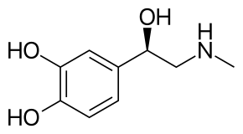
(R) -4-[1-hydroxy-2-(methylamino)ethyl]-benzol-1,2-diol

epinephrine (adrenaline) is obtained synthetically. It is available as adrenaline hydrochloride and adrenaline hydrotartrate.
Adrenaline has a direct stimulating effect on α- and β-adrenergic receptors.
Effect of adrenaline in high dosesα adrenergic receptors of single-vessels and increase in blood pressure. Then the pressor effect of adrenaline is replaced by mild hypotension, which is usually associated with a longer excitation. β2 vascular adrenoreceptors.
relaxes the muscles of the bronchi and relieves bronchospasm,
reduces the tone and motility of the gastrointestinal tract, dilates the pupils and reduces IOP.
increases glycogenolysis (increased blood sugar) and lipolysis (increased lipid content in blood plasma).
Stimulating β one -adrenergic receptors of the heart, adrenaline increases the strength and frequency of heart contractions, and in connection with this, shock and minute release of blood, at the same time, oxygen consumption by the myocardium increases.
Adrenaline in therapeutic doses does not have an obvious effect on the central nervous system. But sometimes there may be anxiety, headache, tremors.
Application:
with anaphylactic shock and other allergic reactions,
with attacks of bronchial asthma,
hypoglycemic coma, with cardiac arrest,
with hypotension and collapse.
As a local vasoconstrictor, it is used as a part of drops and ointments in ophthalmology, otorhinolaryngology, for capillary bleeding, it is added to solutions of local anesthetics to prolong their effect.
Side effects:
increased blood pressure, arrhythmia, heart pain, hyperglycemia.
Adrenaline is contraindicated in hypertension, severe atherosclerosis, diabetes mellitus, thyrotoxicosis, coronary artery disease, pregnancy.

Norepinephrine (Norepinephrine).
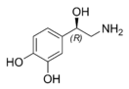
L-1-(3,4-dioxyphenyl)-2-aminoethanol
Norepinephrine is available as hydrotartrate. Its action is associated with a dominant effect on a-adrenergic receptors, causing vasoconstriction and an increase in blood pressure. The cardiotonic effect of norepinephrine is associated with its stimulating effect on adrenergic receptors of the heart.
Norepinephrine is used in conditions accompanied by a sharp drop in blood pressure.
Side effects with the use of norepinephrine are rare. Arrhythmia, headache, shortness of breath are possible.
α - adrenomimetics:
Phenylephrine (Mezaton)

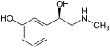
1-​(metha-Hydroxyphenyl)​-​2-methylaminoethanol
Midodrin (Gutron)
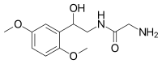
2-Amin-N-[2-(2,5-dimetoxyphenyl)-2-hydroxyethyl]acetamide
Naphazolin (Naphthyzinum)
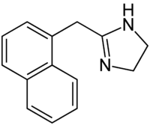
4,5-Dihydro-2-(1-naphtalenylmethyl)-1H-imidazol
Xylometazolin (Galazolin)
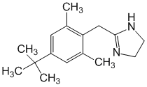
2-[[4-(1,1-Dimethylethyl)-2,6-dimethylphenyl]methyl]-4,5-dihydro-1H-imidazol
Oksimetazolin (Nazol)
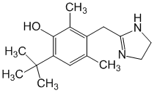
3-[(4,5-Dihydro-1H-imidazol-2-il)methyl]-6-(1,1-dimethylethyl)-2,4-dimethylphenol
Tetrizolin (Tizin)
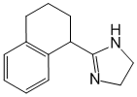
4,5-Dihydro-2-(1,2,3,4-tetrahydro-1-naphtalenyl)-1H-imidazol

They have a direct stimulating effect on αone- and α2-adrenergic receptors.
Phenylephrine (mesaton) mainly acts on αone- adrenoreceptors
It causes narrowing of arterioles and an increase in blood pressure.
Mezaton is used to increase blood pressure during collapse and hypotension, rhinitis (causes vasoconstriction and reduces swelling of the nasal mucosa), conjunctivitis, dilates the pupil.
Contraindicated in case of hypertension, atherosclerosis, vasospasm.
Phenylephrine is a part of combined preparations for the treatment of colds: Rinzasip, Rinza, Teraflu, Coldrex, Coldact, Vicks active symptomatic.
Midodrine increases blood pressure by increasing the tone of arterioles. It is used for hypotension, circulatory disorders.
Contraindicated in case of hypertension, pheochromocytoma, severe kidney failure, glaucoma.
Nafazolinαone,α2- has adrenomimetic, vasoconstrictive effect. When applied to the mucous membranes, it has an anti-inflammatory (decongestant) effect.
Duration of action is 4-6 hours.
Facilitates nasal breathing with rhinitis.
It is used for acute rhinitis, sinusitis, runny nose.
When applied, the phenomenon of tachyphylaxis, increased blood pressure, headache, depression of the central nervous system is possible.
Xylometazoline reduces hyperemia and swelling of the mucous membrane of the nasopharynx and the amount of secretion. In inflammatory and allergic conditions, it restores the openness of the nasal passages and facilitates nasal breathing.
Duration of action is 8-10 hours.
β1β2 - adrenomimetics:
Isoprenaline (Izadrin).
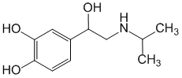

4-[1-Hydroxy-2[(1-methylethyl)amino]ethyl]-1,2-benzendiol
Orciprenaline (Asthmopent)
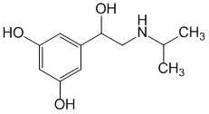
5-[1-Hydroxy-2-[(1-methylethyl)amino]ethyl]-1,3-benzendiol
Isoprenaline has a direct stimulating effect on β1- and β2-adrenergic receptors. The main effect of the drug is associated with its effect on the heart and smooth muscles. By stimulating the β1-adrenergic receptors of the heart, it increases the strength and frequency of heart contraction, facilitates atrioventricular conduction, and increases automaticity of cardiomyocytes.
Expands blood vessels, lowers blood pressure. It is used in the form of tablets under the tongue (sublingually) for atrioventricular blockade, it can be used as a bronchodilator drug.
For these purposes, aqueous solutions for inhalation and tablets for absorption in the oral cavity are used.
Side effect:
tachycardia
increases the oxygen demand of the myocardium, with its use there is a risk of arrhythmia
hand tremors
Orciprenaline is a stimulant of β1- and β2-adrenergic receptors, but compared to isoprenaline, it has a more selective effect on β2-adrenergic receptors of the bronchi than on β-adrenergic receptors of the heart and blood vessels, therefore, it lowers blood pressure and causes tachycardia to a lesser extent.
In the form of inhalation and internally, it is used to prevent and stop attacks of bronchial asthma.
β2 - adrenomimetics (selective drugs):
Dobutamine
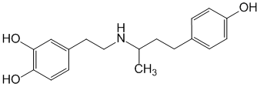
(±)-4-[2-[[3-(4-Hydroxyphenyl)-1-methylpropyl]amino]ethyl]-1,2-benzendiol
Salbutamol
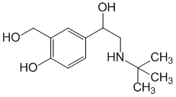
4-[2-(tert-butilamino)-1-hydroxyethyl]-2-(hydroxymethyl)phenol
Fenoterol
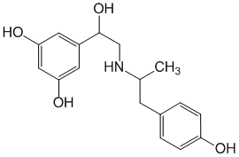
5-[1-Hydroxy-2-[[2-(4-hydroxyphenyl)-1-methylethyl]amino]ethyl]-1,3-benzendiol
Terbutalin.
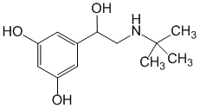
5-[2-[(1,1-Dimethylethyl)amino]-1-hydroxyethyl]-1,3-benzendiol
Dobutamin (Dobutrex)
It increases the contraction force of the heart and increases the heart rate.
It is used as a cardiotonic agent in acute heart failure.
β2-adrenergic receptors are found in the bronchi, uterus, and blood vessels. When these receptors are stimulated, the smooth muscles of the bronchi relax, the tone and contractile activity of the myometrium decreases, and the blood vessels expand.
Salbutamol (Ventolin),
terbutaline (Bricanil),
Fenoterol (Berotek),
Berodual (β2-agonist fenoterol and M-anticholinergic ipratropium bromide),
Hexoprenaline (Ginipral, Ipradol),
Formoterol (Foradil)
Salmeterol (Serevent).
They are used as a bronchodilator for bronchial asthma, chronic bronchitis, to protect pregnancy during miscarriage.
Side effect: tachycardia (reflex) that occurs in response to a decrease in blood pressure;
tremor (due to stimulation (β2-adrenergic receptors of skeletal muscles);
anxiety, increased sweating, dizziness.
Non-selective β1-, β2-agonists isoprenaline and orciprenaline are used in a short course to improve atrioventricular conduction and increase the rate of bradycardia.
β1-agonists: dopamine and dobutamine have a positive varinotropic effect. Their use is limited and prescribed for a short period of time, acute heart failure is related to myocardial infarction, myocarditis. Sometimes they are used for exacerbation of chronic heart failure in decompensated patients with heart defects and ischemic heart disease. Long-term use of this group of drugs leads to increased mortality.
Short-acting β2-agonists, such as fenoterol, salbutamol and terbutaline, are used in the form of aerosols to stop an attack of suffocating bronchial asthma, chronic obstructive pulmonary disease (COPD) and other broncho-obstructive syndromes. Fenoterol and terbutaline are used intravenously to reduce the activity and are under threat.

long-acting β2-agonists: salmeterol is used for prevention, and formoterol in the form of metered aerosols is used for both prevention and relief of bronchospasm in bronchial asthma and COPD. They are often combined in the same aerosol inhaled glucocorticosteroids for the treatment of asthma and COPD.

Indirectly acting adrenomimetics (sympathomimetics):
Ephedrine hydrochloride.
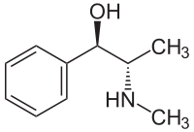

2-methylamino-1-phenylpropanol-1
Ephedrine is an alkaloid derived from the Ephedra plant. Ma Huang, a drug containing ephedrine, was invented in China in BC. Although ephedrine, the active ingredient, has been known since 2000 BC, it was not isolated until 1885. The compound is sympathomimetic with a mixed mechanism of action. Since it has two asymmetric carbon atoms in its structure, it has four enantiomers. Erythroracemate is defined as ephedrine and treoracemate is defined as pseudoephedrine. Natural ephedrine is in the D(-) configuration and is the most active of the four isomers.
Ephedrine mimics adrenaline in terms of its physiological effects. However, its hypertensive effect and local vasoconstrictor effect last longer than epinephrine. Ephedrine hydrochloride increases the force and frequency of heart contractions and constricts blood vessels, resulting in increased blood pressure.
Synthesis of Ephedrine:
Option 1
Option 2. Stereoselective synthesis of ephedrine (Nuberg, 1921)
Option 3. Synthesis by the Fourney method
ephedrine metabolism. Ephedrine is metabolized in the liver, and both the drug itself and its metabolites are excreted in the urine. The main metabolite of ephedrine is norephedrine, which is formed by N-demethylation. Ephedrine also undergoes deamination to form benzoic acid, hippuric acid, and 1-phenylpropane-1,2-diol.

Ephedrine dilates bronchi, reduces intestinal motility, dilates pupils (does not affect accommodation), increases blood glucose, increases skeletal muscle tone.
Ephedrine has a stimulating effect on the central nervous system:
- reduces the feeling of fatigue, the need for sleep, and increases efficiency.
Ephedrine is used as a bronchodilator.
To stop attacks of bronchial asthma, the drug is administered subcutaneously, and for prevention it is administered internally (it is part of the combined preparations "Teofedrine", "Solutan", "Bronholitin").
Ephedrine is used as a bronchodilator.
To stop attacks of bronchial asthma, the drug is administered subcutaneously, and for prevention it is administered internally (it is part of the combined preparations "Teofedrine", "Solutan", "Bronholitin").
Side effect:
nervous excitement,
insomnia,
trembling limbs
loss of appetite
urinary retention.
The drug is contraindicated in insomnia, hypertension, atherosclerosis, hyperthyroidism.

Excited amines
Central sympathomimetic compounds have been developed because the effects of these compounds are superior to peripheral effects.
In addition to central nervous system stimulating effects, anorexigenic appetite-reducing effects with increased arousal and arousal are also observed. Although the central effects are based on a sympathomimetic noradrenergic basis, they can also be dopaminergic and serotonergic.
Adrenostimulants have a beta-phenylethylamine structure that carries a methyl group in the alpha position.
Anorexinogens:
Do not use in patients under 18 years of age.
Captagon is the trade name for the drug phenethylline, which was developed in West Germany in the 1960s. It has been marketed for use as a psychostimulant under the brand names Captagon, Biocapton and Fitton. Abuse of the brand name Captagon phenetylline is common in the Middle East[9], and counterfeit versions of the drug still exist despite being illegal.[ten][eleven]Captagon is less common outside the Middle East, to the point where police do not recognize the drug.
Cathinone, norephedrone, β-ketoamphetamine -monoamine alkaloid is included in Katya (Catha Edulis) -shrubs in the Bereskletovye family, which grows in East Africa and continues on the Arabian Peninsula. Ephedrine, Katina, methcathinone and amphetamines are close to it in terms of their effects on the body. Probably the most effective among the derivatives of Catha edulis, also known as psychostimulants. Cathinone differs from many other amphetamines in that it belongs to the functional group ketone.
compared to amphetaminecathinone shows a lower level of stimulant and toxic properties [one].

Adrenoblockers.
Adrenoblockers, antiadrenergic drugs, adrenolytics, sympatholytics - drugs that inhibit sympathetic stimulation or block the effect of sympathomimetics. Ergoalkaloids, whose pharmacological effects were identified by Dale in 1906, are the first known antiadrenergic compounds.
α1α2-blockers:
Phentolamine
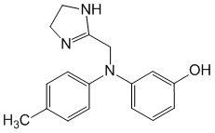
3-[[(4,5-Dihydro-1H-imidazol-2-il)methyl](4-methylphenyl)amino]phenol
Tropafen
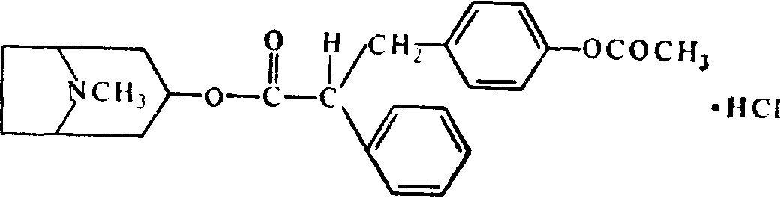
Dihydroerqotamin (Vazobral)
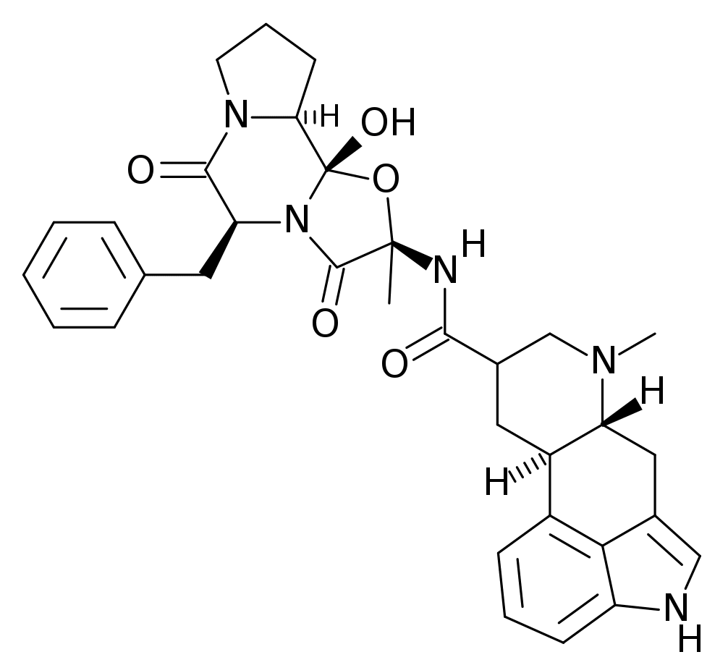
(5'alfa,10alfa)-9,10-Dihydro-12'-hydroxy-2'-methyl-5'-(phenylmetyl)ergotaman-3',6',18-trion
Dihydroergotoxin
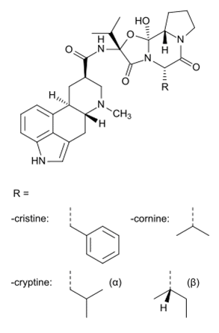
Pirroxan (Proroxan)
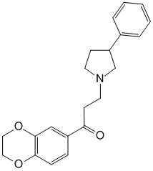
1-(2,3-Dihydro-1,4-benzodioxine-6-il)-3-(3-phenyl-1-pirrolidinyl)-1-propanone
α1-blockers:
Prazosin (adverzuten)
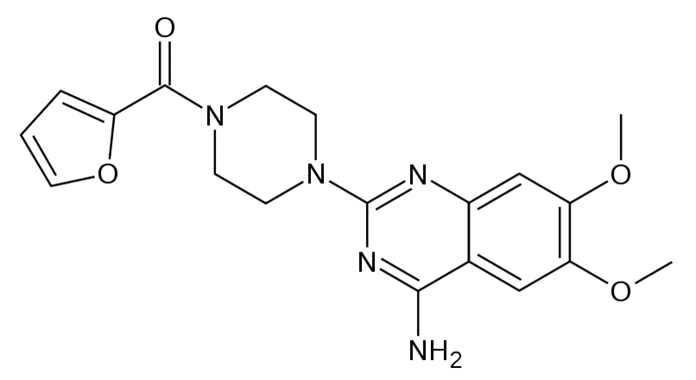
1-(4-Amino-6,7-dimetoxy-2-kinazolinyl)-4-(2-furanylkarbonyl)piperazin
Terazosin (kornam)
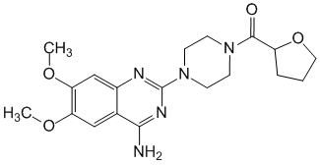
1-(4-Amino-6,7-dimetoxy-2-kinazolinyl)-4-[(tetrahydro-2-furanyl)karbonyl]piperazin
Doxazosin (Kardura, Tonokardin)
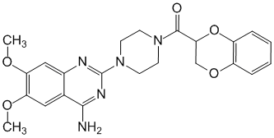
1-(4-Amino-6,7-dimetoxy-2-kinazolinyl)-4-[(2,3-dihydro-1,4-benzodioxin-2-il)carbonyl]piperazin
Tamsulosin (Omnik)
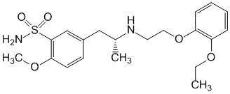
α₂- adrenoblocators
Nicergoline (Sermion)
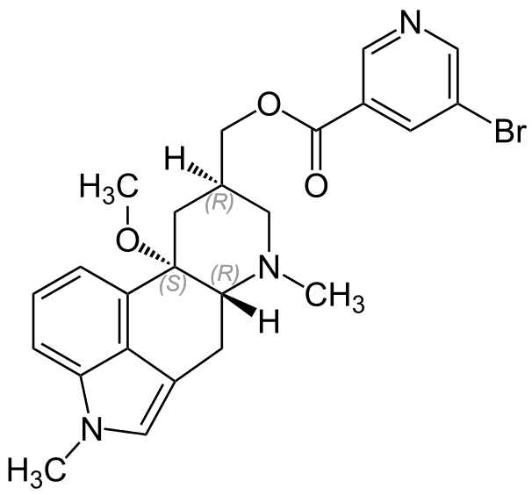
(8beta)-10-methoxy-1,6-dimethylergoline-8-methanol 5-bromo-3-pyridinecarboxylate
Adrenergic receptor blockers are divided into six groups.
Ergoalkaloids
β-Haloalkylamines
Imidazolines
Quinazoline derivatives
Compounds with hydrazinophthalazine structure and similar derivatives
Combinations of various nature
Blockade of adrenoblockers inhibits α1- and α2-adrenergic receptors and transmission of excitation in adrenergic synapses.
Blockade of a1-adrenergic receptors leads to a decrease in the tone of arterial and venous vessels, causes a decrease in peripheral vascular resistance and blood pressure, improves blood supply to peripheral tissues.
The oxytoxic effect of ergot was recognized in the early 16th century and was used by midwives until it gained professional recognition in medicine. For many years, ergotoxin, isolated in 1906, and ergotamine, isolated in 1920, were considered the only alkaloids found in the plant. Later studies revealed that ergotoxin is a mixture of three alkaloids: ergocornine, ergocristine, and ergocriptine. Sensibamine was introduced in 1933 as a new base and was later found to be an equal mixture of ergotamine and ergotamine. To date, more than 80 ergoalkaloids have been isolated. The common structure of all of them is the tetracyclic ergoline ring system.
Ergotamine, as well as alkaloids of the ergotoxin group, such as ergocornine, ergocristine, alpha-ergocriptine and beta-ergocriptine, ergometrine containing ergonovine and ergobase, are ergot alkaloids (ergoline alkaloids, ergoloids - French ergoroids - of medical importance. These alkaloids are related to D-lysergic acid or based on 6-methylergoline. According to the chemical structure, according to the location of the substituents, ergoline alkaloids are divided into the subgroup of lysergic acid amides (for example, ergometrine) and the subgroup of peptide alkaloids (for example, ergotamine).
Dehydrogenated derivatives have the most pronounced property among ergoline alkaloids to block alpha-adrenergic receptors, such as dihydroergotamine and dihydroergotoxine, due to which they can have a vasodilating effect and consequently reduce blood pressure, while non-hydrogenated derivatives have the opposite properties. Ergoloids also have a stimulating effect on serotonergic activity and dopamine receptors.
Derivatives of ergot alkaloids are used as medicinal preparations for the treatment of migraine, prostate hyperplasia, uterine atony and uterine bleeding, endocrine pathologies, arterial hypertension, neurotic conditions, cerebrovascular accidents, as well as a number of other pathologies.
Epimerization of ergoalkaloids:
Synthesis of substances from polypeptide ergoalkaloids of natural origin:

β-haloalkylamines: compounds of this group produce slow-developing, long-lasting blockade when administered in appropriate doses.
Dibenamine (N,N-dibenzyl--chloroethylamine)

The long-term blocking effect of the compounds on β-receptors is associated with the aziridinium (ethyleneiminium) ion formed as an intermediate:
β-receptor nucleophile (Nu)
δ+ Alkylated -receptor
Phenoxybenzamine hydrochloride: N-(2-chloroethyl)-N-(1-methyl-2-phenoxyethyl)benzylamine hydrochloride

Imidazolines are competitive non-selective short-acting alpha-receptor blockers.
Phentolamine
2  N --(3 Hydroxiphenyl)N --(4 methylphenyl)aminomethyl imidazolin
Tolazolin
2-benzyl-2-imidazolin hydroxlorid hidroxlorid
(2Benzyl-4,5-dihydro-1H-imidazol)
Phentolamine (lat. Phentolaminum) is a white crystalline powder, sometimes cream-colored. The chemical structure of phentolamine is similar to clonidine - a centrally acting antihypertensive drug - but unlike it, it has an alpha-adrenergic blockade that causes expansion of peripheral vessels (especially arterioles and precapillaries), which in turn causes a decrease in arterial and venous pressure; also improves tissue trophism and blood supply of the mucous membrane. Due to these effects, phentolamine has been used in the treatment of peripheral circulatory disorders, trophic ulcers of the lower limbs, bedsores, frostbite, slow ulcers, as well as for the diagnosis and elimination of hypertensive crises associated with pheochromocytoma.
Phentolamine is a more potent α-adrenergic antagonist than tolazoline, but both drugs are used for antihypertensive purposes. These compounds have alpha1 and alpha2 adrenoceptor antagonist activity and cause tachycardia. Both compounds have a direct vasodilating effect on vascular smooth muscle.
Tolazoline is an alpha-adrenergic antagonist, its effect is relatively weak, but the agonistic effect of the compound, such as histamine and acetylcholine, causes a vasodilator effect.
Quinasol derivatives:
Prazosin (6-8 hours), terazosin (24 hours) and doxazosin (up to 36 hours) reduce blood pressure, they are used for arterial hypertension; internally managed.
(Tamsulosin: Omnik) is effective in urinary tract disorders associated with benign prostatic hyperplasia.
Derivatives of various compounds.

These compounds are selective alpha1-adrenergic antagonists. By this mechanism, they dilate arterioles and venules. It lowers blood pressure by reducing peripheral vascular resistance. It is used in congestive heart failure because it reduces the ability of the heart to pump blood to the environment. It is used in the treatment of hypertension and congestive heart failure.
Nicergoline (sermion) is a derivative of ergot and nicotinic acid. has 2-adrenergic blockade and spasmolytic activity, dilates cerebral and peripheral vessels. It is used for disorders of cerebral and peripheral blood circulation, migraine, optic nerve ischemia.
Undesirable effects are possible: hypotension, dizziness, itching, dyspepsia.
In 1948, Alquist described β 1 and β 2 adrenergic receptors.
Powell and Slater showed that dichloroisoproterenol (=DCI) is a selective beta-blocker, the desired effect is β 1 blockade (cardiac effect), β 2 blockade (bronchial effect): asthmatic attacks and bronchospasm. As for the effect of beta-blockers, only β1 blockade is desired: They are used in cases of angina pectoris, hypertension and arrhythmia.
Most β-blockers are derivatives of 1,2-propanediol.
The α-carbon is replaced by a phenoxymethyl group instead of phenyl.
The α-carbon configuration is important for the antagonistic effect.
The D-enantiomer or R,S (erythro) diastereomers are more effective derivatives (levogyr isomers are 50-100 times more effective).
β1β2 - blockers:
Propranolol (Anaprilin);
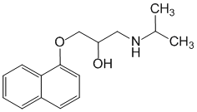
1-[(1-methylethyl)amino]-3-(1-naftalenyloxy)-2-propanol
Oxprenolol.
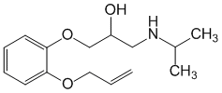
1-[(1-methylethyl)amino]-3-[2-(2-propenyloxy)phenoxy]-2-propanol
β1 - blokerlər (cardioselective):
metaprolol;
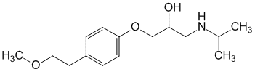
(±)-1-[4-(2-Metoxyethyl)phenoxy]-3-[(1-methylethyl)amino]-2-propanol
talinolol;
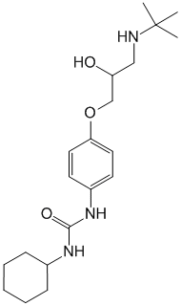
(±)-N-cyclohexyl-N'-[4-[3-[(1,1-dimethylethyl)amino]-2-hydroxypropoxy]phenyl]carbamid
bisoprolol
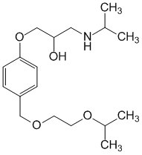
1-[4-[[2-(1-Methylethoxy)ethoxy]methyl]phenoxy]-3-[(1-methylethyl)amino]-2-propanol
Nevibolol
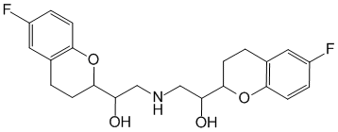
alfa, alfa'-[Iminobis(methylen)bis[6-fluoro-3,4-dihydro]-2H-1-benzopiran-2-metanol; A racemate consisting of D- and L-enantiomers
Atenolol.
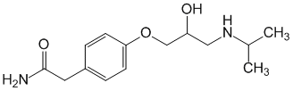
4-[2-Hydroxy-3-[(1-methylethyl)amino]propoxy]benzenacetamid
Sotalol
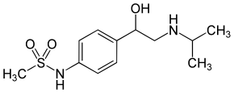
N-[4-[1-Hydroxy-2-[(1-methylethyl)amino]ethyl]phenyl]metansulphonamid
Chemical classification:
Derivatives of 1-substituted aryl (heteroaryl) 1,2-dihydroxy-3-aminopropane:
Ethanolamine 2-substituted aryl (heteroaryl) derivatives:
Sotalol synthesis:
Metabolism:
1 Phenol oxidation
2 Side chain oxidation
Propranolol undergoes first-pass metabolism. Oral bioavailability is about 30%.

Metoprolol undergoes a first-pass effect similar to propranolol after oral administration. Oral bioavailability is 50%. However, it does not produce active metabolites like propranolol.
metabolic pathways
- by demethylation O, desmethylmetoprolol O - The resulting product is rapidly oxidized to 4-(2-hydroxy-3 isopropylaminopropoxy) phenylacetic acid (II).
- By oxidative deamination
,
- Formation of alpha-hydroxymetoprolol (IV) by aliphatic hydroxylation
- N-dealkylation of the deisopropyl derivative, deamination and oxidation of the resulting aldehyde
Smoking causes metabolic side chain oxidation and propranolol glucuronidation.
Hydrophilic compounds are less stored in the liver and excreted by the kidneys.
Lipophilic compounds easily pass into the central nervous system and are metabolized.
Non-selective β-blockers
Blockade of adrenergic receptors located in the myocardium causes a weakening of the strength and frequency of heart contractions;
reduction of myocardial contractility and oxygen demand of the heart;
decreased cardiac output (stroke volume) and decreased blood pressure.
Oppression of 2-adrenergic receptors can cause spasm of the bronchi, increase the tone of the muscles of the uterus, and decrease the processes of glycogenolysis (a decrease in the level of sugar in the blood).
Propranolol is used in the treatment of angina pectoris, cardiac arrhythmias (tachycardia), arterial hypertension, thyrotoxicosis, glaucoma (reduces the secretion of intraocular fluid).
Side effects: bradycardia, general weakness, dizziness, bronchospasm, dyspeptic disorders, increases the tone of the uterus, increases the tone of peripheral vessels (a symptom of cold hands and feet), "withdrawal syndrome".
Non-selective β-adrenergic blockers include Pindolol (visken), Nadolol (corgard), Sotalol (sotalex), Timolol (thymoptic), Oxprenolol (trazicor) and other drugs.

atenolol (Tenormin, Betacard);
tenor (atenolol + diuretic);
metoprolol (Corvitol, Egilok, Vasocardin, Betalok);
talinolol (cordanum);
bisoprolol (Concor); Concor AM (bisoprolol + amlodipine);
betaxalol (Lokren);
nebivolol (without ticket);
acebutalol (Acecor, Sectral).
selectively blocks adrenergic receptors of the heart, reduces the strength and frequency of heart contractions, has an antiarrhythmic effect, lowers blood pressure.
It has almost no effect on β2-adrenergic receptors of the bronchi and blood vessels, to a lesser extent causes narrowing of peripheral vessels and bronchospasm, does not cause hypoglycemia.
It is used to treat angina pectoris, cardiac arrhythmias, arterial hypertension.
Undesirable side effects are possible: feeling of heat, dizziness, dyspepsia.
Labetalol (Coreton, Trandate)

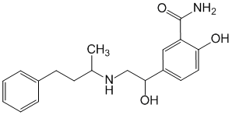
Karvedilol(kardivalar, talliton, dilatrend)
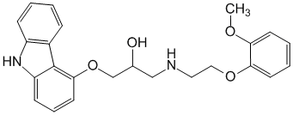

(±)-1-(9H-Carbazol-4-yloxy)-3-[[2-(2-methoxyphenoxy)ethyl]amino]propanol
blocking - and -adrenergic receptors. It is used for angina pectoris, myocardial infarction, chronic heart failure, arterial hypertension.

Sympatholytics:
Octadine (Guanetidine)
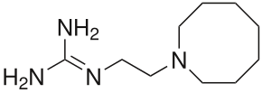
2-(2-Azocan-1-ilethyl)quanidin
Rezerpin.
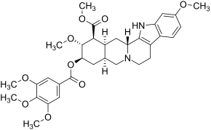

Methyl 11,17α-dimethoxy-18β-[(3,4,5-trimethoxybenzoyl)oxy]-3β,20α-yohimbane-16β-carboxylate
Sympatholytics disrupt the transmission of excitation at the level of the presynaptic membrane by depleting norepinephrine stores in nerve endings or preventing its release. This leads to a decrease in the effect of the sympathetic nervous system on blood vessels and the heart - the vessels dilate, the force of heart contractions decreases, and bradycardia occurs. The result is a decrease in blood pressure.
The sympatholytic effect of octadin is due to its selective accumulation in the granules of sympathetic nerve endings and suppression of the adrenergic mediator from them - norepinephrine. Part of the released neurotransmitter reaches postsynaptic adrenoreceptors and has a short-term pressor effect, but the main part of the mediator is destroyed under the influence of axonal monoamine oxidase. As a result of depletion of norepinephrine reserves in adrenergic endings, the transmission of nerve impulses to them is weakened or stopped.
Octadine is used as an antihypertensive agent. The drug has a strong hypotensive effect and in the right doses can reduce blood pressure in patients with hypertension at various stages, including severe forms with high and persistent pressure.
A reserpine alkaloid plant of the genus Rauwolfia
When using reserpine, systolic and diastolic blood pressure gradually decreases in various forms and stages of arterial hypertension. The hypotensive effect develops gradually (on 6-8 days) and lasts for a relatively long time after stopping the use of reserpine.
When using reserpine, undesirable effects are noted: drowsiness, depression, nasal congestion, spasms of the stomach and intestines, diarrhea, increased secretion of digestive glands and pain in the stomach.
Blockers are also bretylium tosylate, which is a structurally similar compound to guanethidine - guanedrel. Bretylium tosylate is used for antiarrhythmic purposes.

